+–––

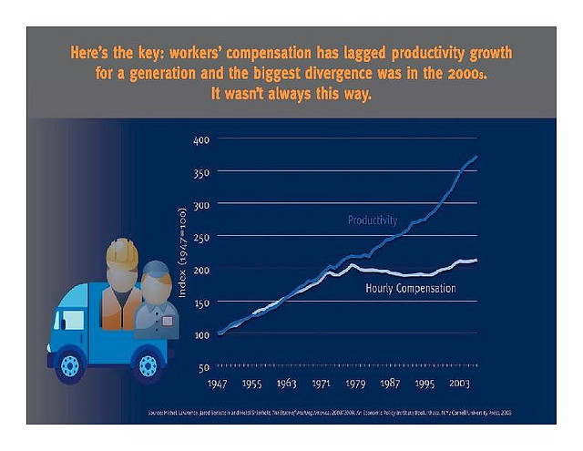

Productivity Wages
See dynamic graph at: http://www.stateofworkingamerica.org/pages/interactive#/?start=1917&end=1961

Note that blue graph above uses manufacturing productivity only, not overall productivity.

Therefore see: https://fred.stlouisfed.org/series/LABSHPUSA156NRUG

